Project name - Tic Tac Toe Game

Developer Name - Suraj Uttachand Oswal

Description - This is a classic two-player Tic Tac Toe game implemented using HTML, CSS, and JavaScript. The game provides a simple interface where two players take turns marking the cells of a 3x3 grid. It detects wins, draws, and maintains scores for both players. Sound effects and animations enhance the user experience

Objective - the objective of this project is to create simple and relaxing game to play.

Purpose - I always wanted to create games but I'm still at a beginner stage that why, I think this game is a good one to start with.

Problem face - As a beginner, I face some problem to development such as designing game board layout and making them responsive. But get help by AI and youtude video, I learn many new thing.

Languages uses - HTML, CSS and JS.

Features -

1. Interactive Gameplay

* Players take turns marking cells on a 3x3 grid.
* "X" always starts the game.

1. Automatic Winner Detection

* Highlights winning combinations with a visual line.

1. Draw Detection

* Declares a draw when all cells are filled without a winner.

1. Score Tracking

* Tracks the score of both players ("X" and "O") during gameplay.

1. Audio Effects

* Background music, move sound, winning sound, draw sound and button click effects.

1. Reset Game Options

* Reset the board while retaining the score.
* Full reset option to reset scores and the board.

1. Responsive Design

* Adaptable for different screen sizes.

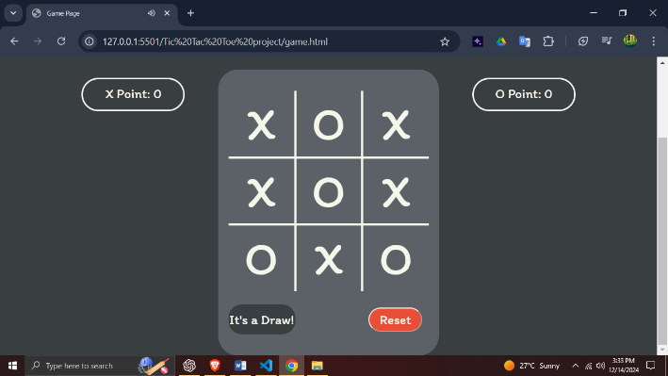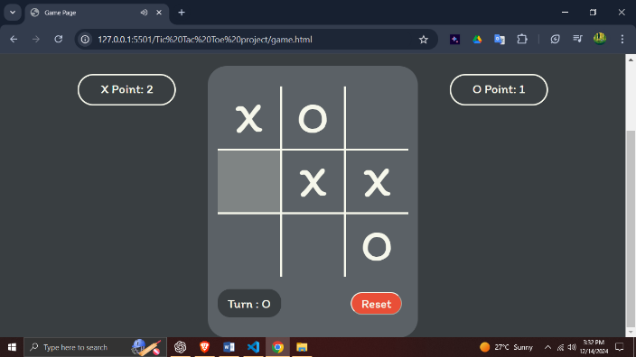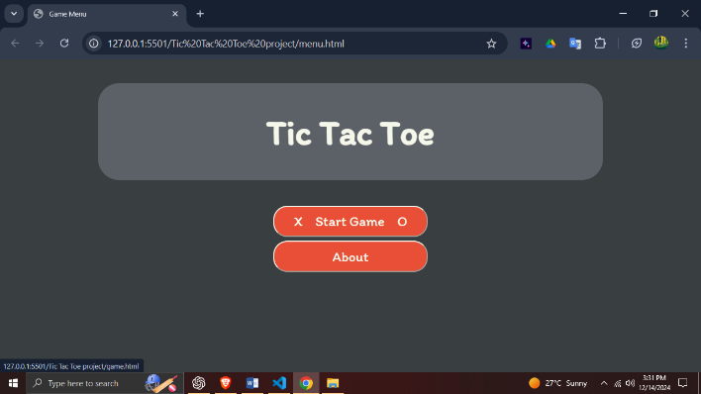Screenshots -

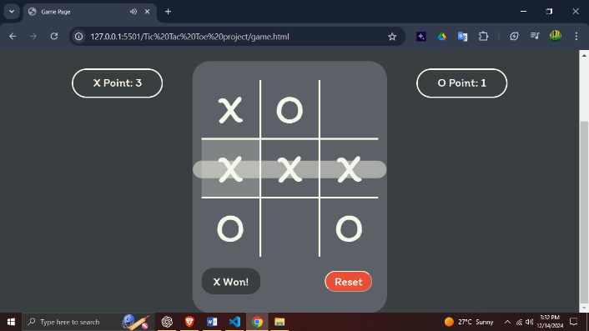

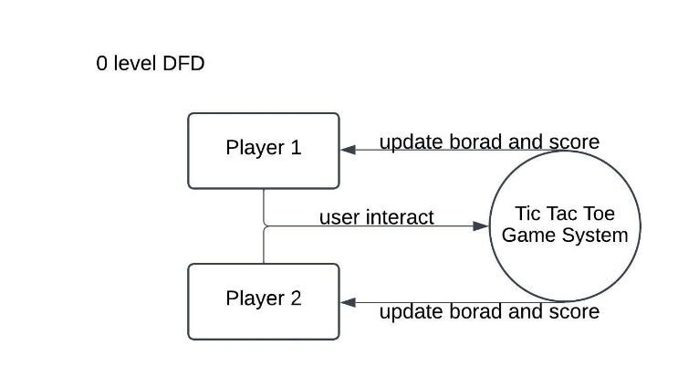Data Flow Diagram -

Future Enhancements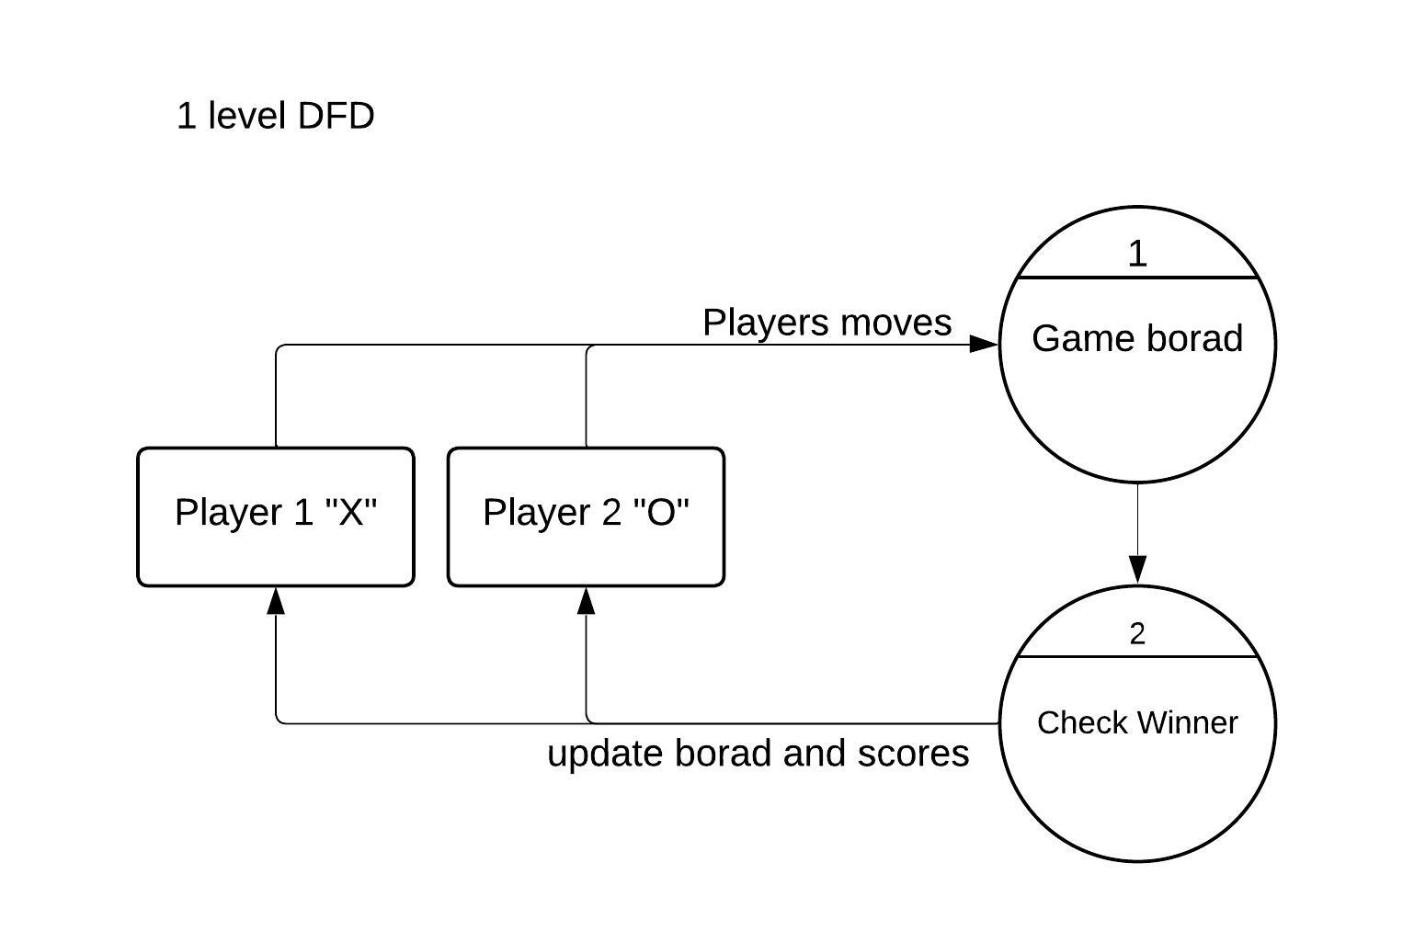 –

* Add an AI player and computer player.
* Add tournament.
* 4x4 game and above.
* Add themes and color customization for the game.
* Add a timer for each player’s turn.
* Multiplayer game (play with global player).

Conclusion - this tic tac toe is a simple yet feature-rich game designed for two players. It demonstrates a solid understanding of javascript DOM manipulate, CSS styling and event handling. By adding interactive sound effects and animations the game provides an engaging user experience.